For office use only
- Assessed Date Matched with
Revised Sept 2026 Date
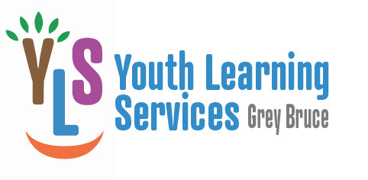

LEARNER APPLICATION

Learner’s Name Date of Birth (dd/mm/yy)
Adult contact name
Relationship to learner______________________________________________
Is anyone else involved in decision-making for this learner? __________________________________________________________
Address and Box #
Phone Number: Home Work _____
E-mail Address

Learner’s Current Grade School
Learner’s interests and hobbies
School Assistance?
School Assessments? Results?

What do you hope to achieve with a tutor?
Do you have a preference for where learning assistance will take place? (Name of town and location) ______________ ____
We match volunteers to learners, in part, by geographic area. How far are you willing to travel? (town/distance)_______________________________________

Is there anything else we should know about in order to meet the needs of this learner?__________________________________________________________________________________________________________________________
How did you hear about our program?_______________________________

Would you consider making a donation to our organization to assist us with providing this service? ______________________ (A charitable receipt will be provided.)

If you are interested in becoming involved with the GBYLS you could:
- Become a learning assistant/tutor
- Help with fundraising events
- Become a member of our board

Parent /Learner Contract

- I understand that the volunteer cannot discuss the learner by name, or by any identifying description, with friends, family or other agencies, unless the tutor has specific permission from me. (Confidentiality Agreement)

- If I have any problems or concerns, I will bring them to the attention of the Program Coordinator.

- I am willing to make a commitment to the learning arrangement and agree to keep in touch with BGYLS, especially if the match is not meeting my expectations.

- I am willing to release the following information to GB Youth Learning Services to assist their assessments in meeting my son or daughter’s academic and educational needs:
- My phone number as a contact to maintaining learning sessions
- Student’s interests, hobbies
- Educational background

- I understand this information will remain on file but will be shared with our tutor or learning assistant at a match meeting in the interest of benefiting my child’s education.

- I understand that all learning assistants/tutors with the program are volunteers and that they are not permitted to receive remuneration for their efforts on my child’s behalf.

Parent/Guardian_________________ Coordinator_____________ ____

Date: ____________________ _

